High School Basketball Registration Instructions

Go to our website https://cyojwa.org/current-programs.

Click on the 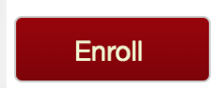button.
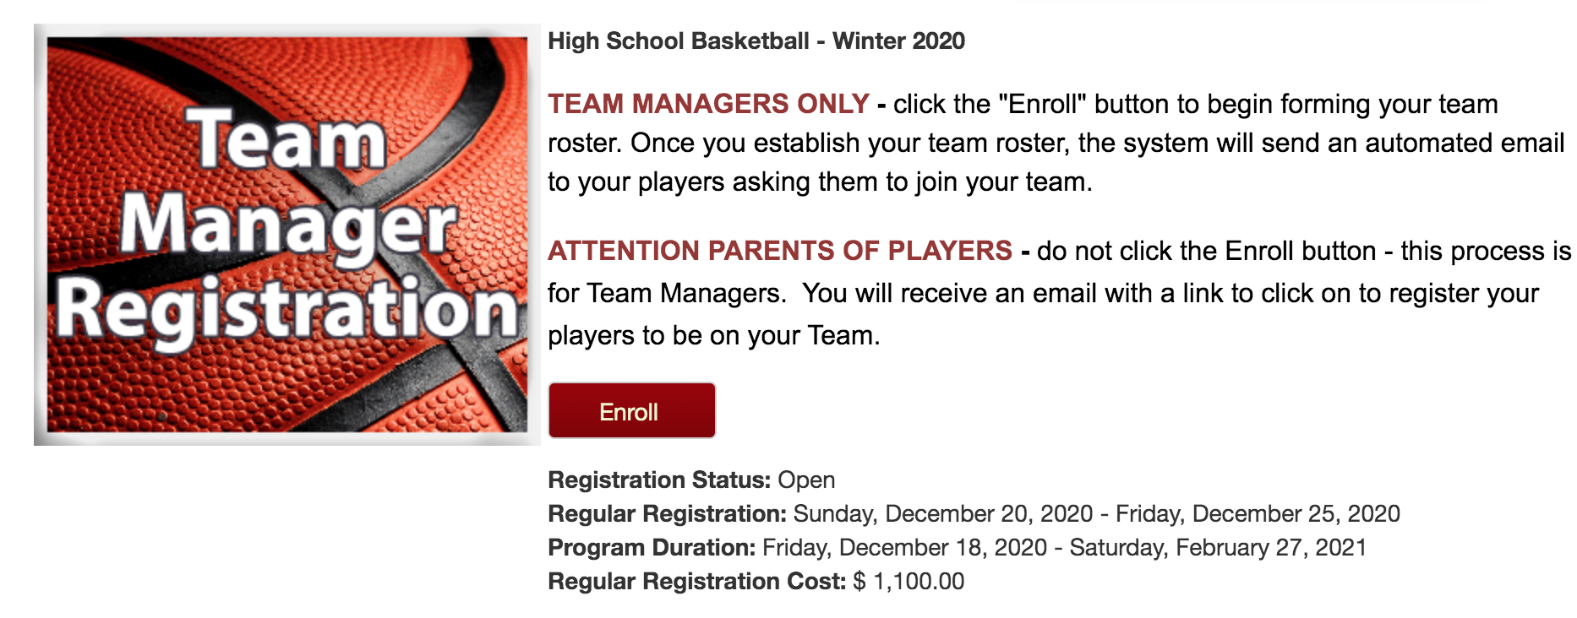
Login using an existing account or setup a new account. If you have an account and you forgot your password you can reset your password.

To set up a new account you will need to fill in the following information.
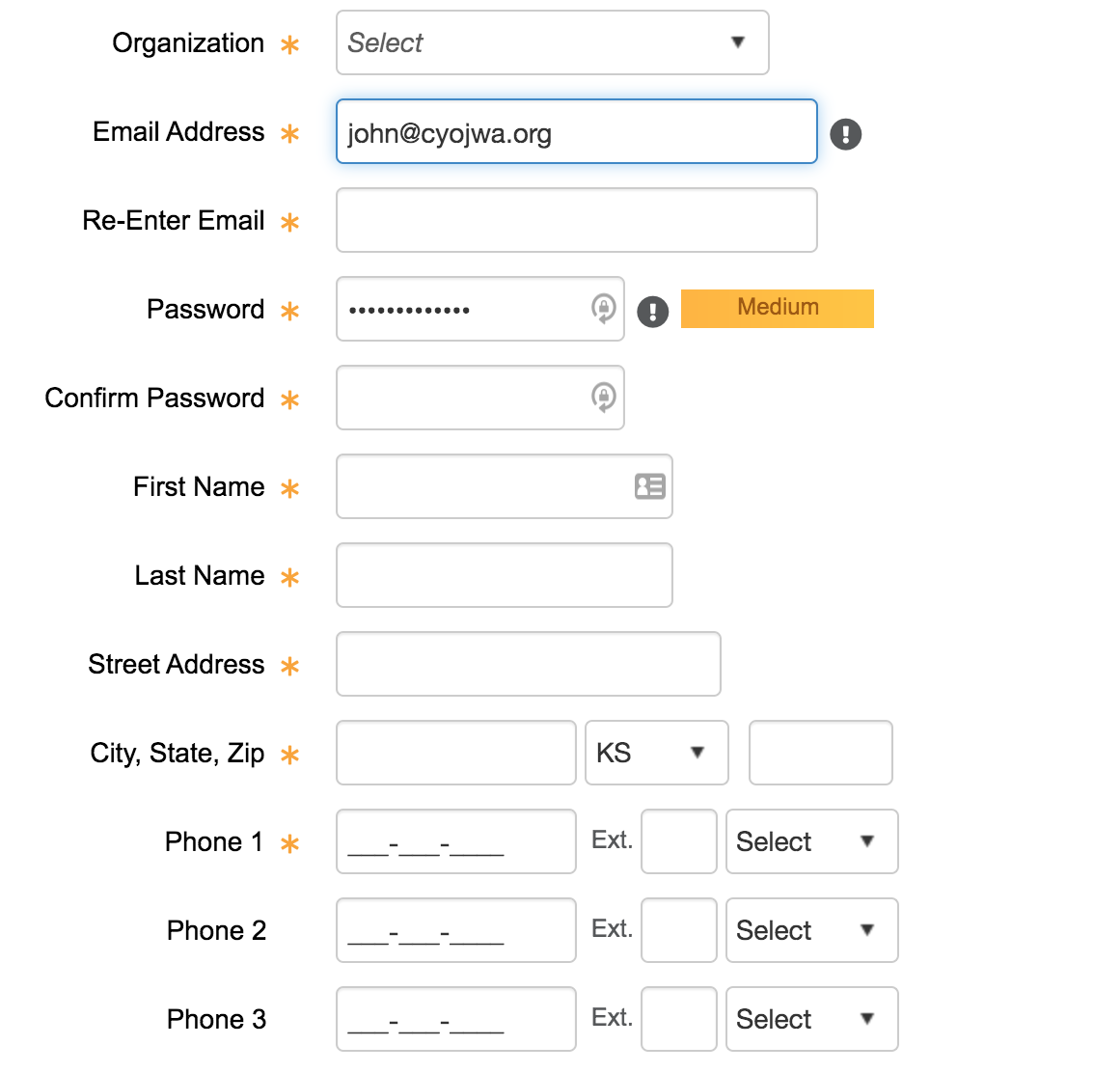
You will enroll yourself as the primary on the account by selecting 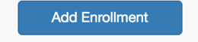
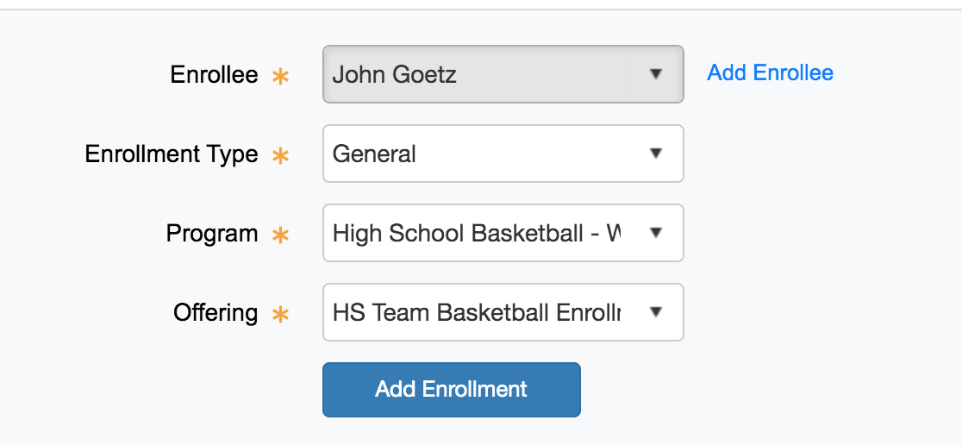

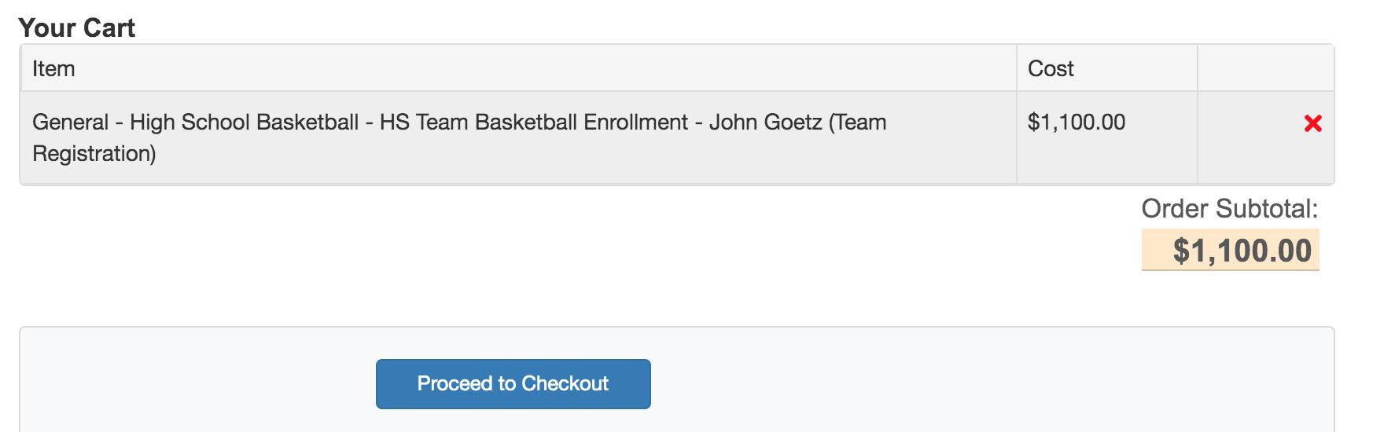
Select 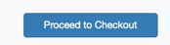

Complete the team info and read and accept the acknowledgements.
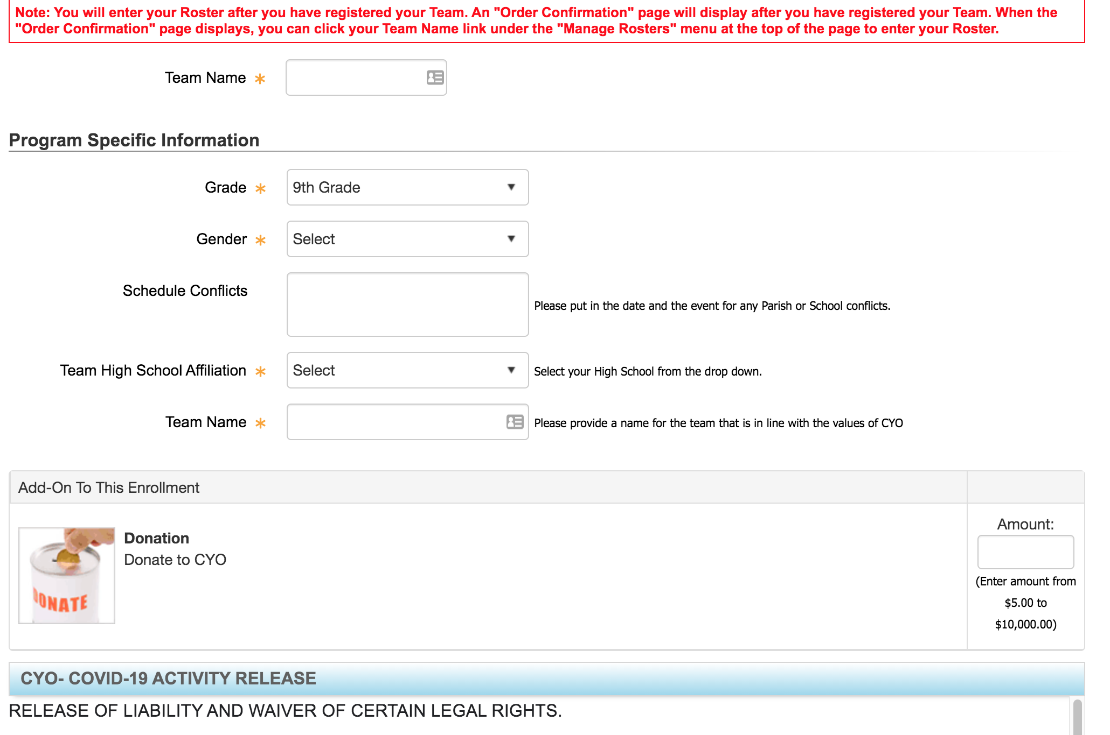

Checkout and make payment. If you are to pay by check, your spot may not be secured until payment is received. Checks can be mailed to Maureen Goetz, 9215 Scott Drive, DeSoto, KS 66018. They can be written to CYO.

You will receive a confirmation.
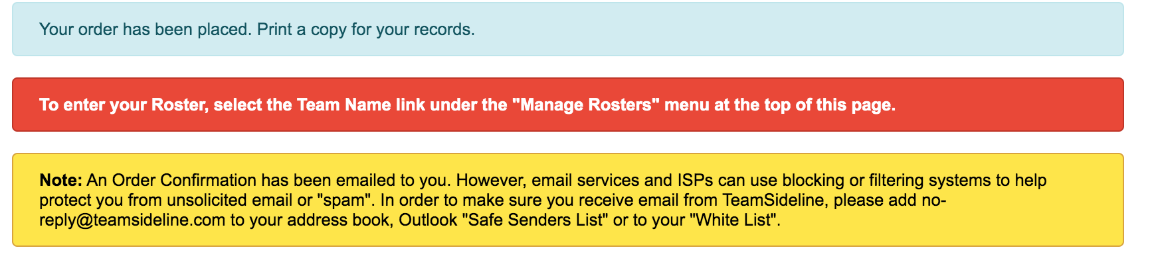
Go to manage rosters.

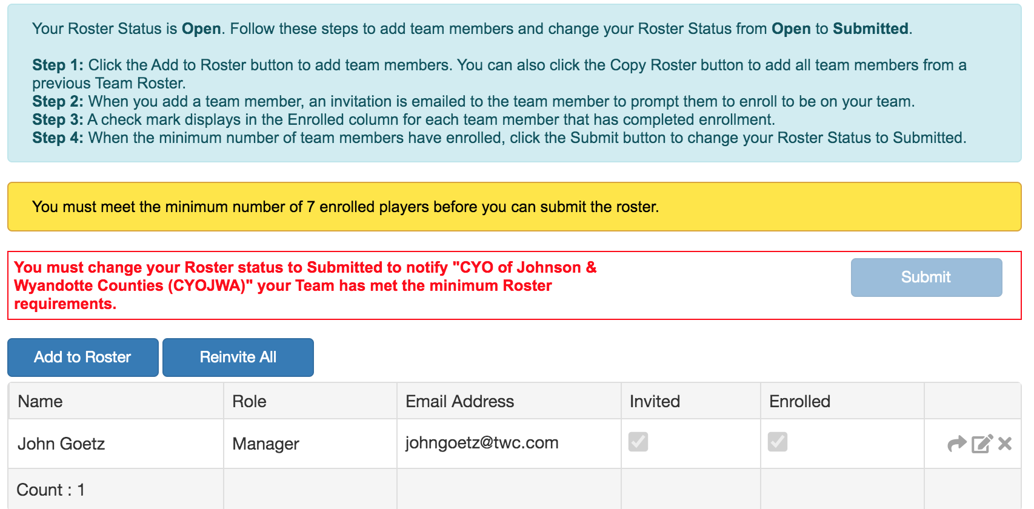
Select 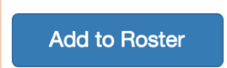and input your minimum of 7 rostered players and their parent or guardian email addresses

Complete for all rostered players.
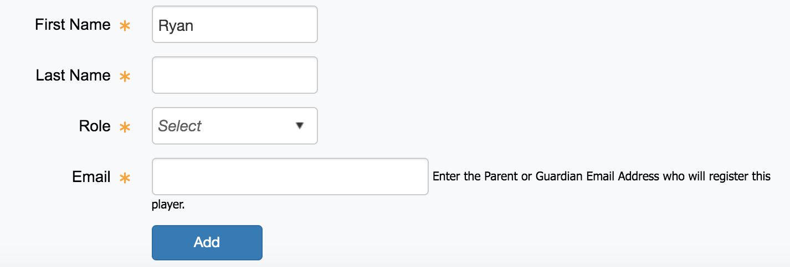

Each rostered player will get an invitation at the email listed above and they will click on the link to register.
The parent will login to their account at the link above and will select enroll. If the child has never been enrolled in CYO they will need to select 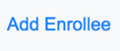.

The parent will need to read and accept all acknowledgements.

Please note: registering, paying and inputting your 7+ players will hold your spot. The players do not have to be enrolled to hold your spot.

Once a team has at least 7 enrolled players, select 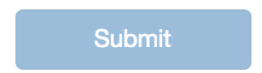.
You can continue to add or delete players from your roster until February 5, 2021.

Please feel free to reach out with any questions at admin@cyojwa.org.

